**Year 7 – Humanities and Social Sciences (2024)**

**Assessment 3– Direct Action (15%)**

|  |  |
| --- | --- |
| **HUMANITIES & SOCIAL SCIENCES ASSESSMENT TASK** | |
| **Year level** | 7 |
| **Subject** | Geography |
| **Title of task** | *Assessment Task 2 – Liveability Portfolio* |
| **Marks and weighting** | 15% |
| **Description of task** | Students will complete an inquiry task to investigate the liveability of their town including people’s perceptions of liveability and the strategies that can be used to increase liveability. |
| **Suggested time** | * 2 weeks in class |
| **DOCUMENTATION** | |
| **Documentation** | * Inquiry Booklet |
| **TEACHER FEEDBACK** | |
| **MARK:**  _____/68 | |

In this Year 7 Geography portfolio task, you will delve into the concept of liveability within the context of your chosen town (where you live). You will explore factors that contribute to or hinder liveability. Through research, analysis, and presentation, you will develop a comprehensive understanding of how various geographical, social, and environmental factors shape the quality of life in different areas of WA.

The Portfolio task is made up of different components. This booklet helps you to record your research. You can choose to use templates provided within this book or create your own versions of the graphic organisers.

You are encouraged to submit your research notes and completed components in a display file.

Follow the checklist on this page carefully to ensure you submit all components.

|  |  |
| --- | --- |
| Town Profile - (Research notes) |  |
| Town Profile poster - (Template Provided) |  |
| Factors Affecting Liveability - (Fishbone Diagram) |  |
| Surveys (x3 minimum - yourself and 2 other people). |  |
| Liveability Assessment of Town – Strengths and Weaknesses (Venn Diagram). |  |
| Data Analysis (Graphs) |  |
| European Strategy – Research notes |  |
| Strategy proposal for town (Written Proposal). |  |
| PMI Chart |  |
| Bibliography |  |

**Town: ________________________________________**

**Part 1 - Town Profile**

|  |  |
| --- | --- |
| **Town Profile** | |
| Location |  |
| Population |  |
| Climate |  |
| Access to Services |  |
| Employment |  |
| Housing |  |

Convert this information into a poster using the template provided to you.

It can be done online using Canva, or on card for your good copy.

**Part 2 – Factors Affecting Liveability**

Complete the fishbone diagram below to identify and explain five (5) geographical, social and/or environmental factors that contribute to liveability. This will need to be recreated on Canva or another program for your good copy.

**Part 3 – Surveys**

Complete the liveability survey yourself, as well as asking a minimum of two other people. These people should be of different age groups.

Surveys have been provided for you at the back of the booklet. – Don’t forget to submit these as well.

|  |  |
| --- | --- |
| **Person 1** | Name: |
| Gender: |
| Age: |

|  |  |
| --- | --- |
| **Person 2** | Name: |
| Gender: |
| Age: |

|  |  |
| --- | --- |
| **Person 3** | Name: |
| Gender: |
| Age: |

**Part 4 – Assessment of Liveability**

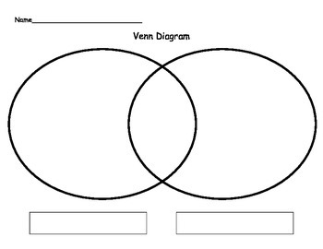Complete the Venn Diagram on this page highlighting some of the strengths and weakness of your town from the completed surveys. *You will need to recreate this on Canva or another program for your good copy.*

WEAKNESSES

STRENGTHS

**Part 5 – Data Analysis**

Convert the data from your surveys into a graph. This can be displayed as a bar graph, column graph, pie graph etc.

You can choose to display your survey information on a single graph.

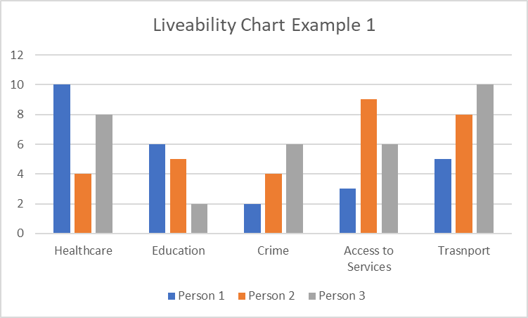

Or in multiple different graphs…..

Separated by Person Or Factor

*Use Microsoft Excel to help you.*

**Part 6 – Strategies to improve liveability.**

Choose one aspect of your town that you want to improve and find a similar strategy that has been used in Europe.

|  |  |
| --- | --- |
| **European Strategy** | |
| Strategy: |  |
| Description: |  |
| Location: |  |
| Implementation: |  |

Apply this strategy to your town, think about how it can be implemented.

|  |  |
| --- | --- |
| **Application of Strategy to _____________** | |
| Purpose: |  |
| Benefits: |  |
| Location: |  |
| Implementation: |  |

You will need to write this information as a good copy where you include a proposal for your chosen strategy. This will need to include, pictures, a map of your town and where it will be located etc.

**Part 7 – PMI Chart**

***You will need to recreate a good copy on Canva or another program***

|  |  |  |
| --- | --- | --- |
| **PLUS**  ***What were the good things?*** | **MINUS**  ***What were the bad things?*** | **INTERESTING**  ***What did you find interesting?*** |
|  |  |  |

**Part 8 – Bibliography** *Please note that in order to obtain full marks you must submit a formal bibliography, the table below is only for recording your references as you are researching or finding images.*

|  |  |  |  |  |
| --- | --- | --- | --- | --- |
| **Author** | **Date last updated** | **Title of Webpage** | **Date accessed** | **HTTP** |
|  |  |  |  |  |
|  |  |  |  |  |
|  |  |  |  |  |
|  |  |  |  |  |
|  |  |  |  |  |
|  |  |  |  |  |
| **Author** | **Date of Publication** | **Title of Book** | **Publisher** | **Place of Publication** |
|  |  |  |  |  |
|  |  |  |  |  |
|  |  |  |  |  |

**Liveability Portfolio (15%) Total ______/68**

|  |  |  |  |  |  |
| --- | --- | --- | --- | --- | --- |
|  | **12-15** | **8 - 11** | **4-7** | **0 - 4** | **Subtotal** |
| **Town Profile** | Provides very detailed, comprehensive and accurate information displayed in poster format.  Includes sources (map of town and picture)  *Al parts of required information included.* | Provides detailed and mostly accurate notes which address the research areas. Some parts of the information is missing. | Provides notes of adequate detail which attempt to address the research areas.  Some parts are missing from notes or poster. | Notes are limited in detail and do not address the research areas.  Uses little evidence from limited sources which have little or no relevance. Notes are not presented in poster format.  No notes are submitted (0) |  |
|  | 8-10 | 5-7 | 2-4 | **0 - 2** | **Subtotal** |
| **Factors affecting liveability** | Five different and accurate factors of liveability are identified and explained in detail.  Information is presented in fishbone diagram format. | Accurate factors of liveability are identified and explained with adequate detail.  Information is presented in fishbone diagram format. | Five different and accurate factors of liveability are identified. No explanation submitted, or explanation is satisfactory..  Information is presented in fishbone diagram format. | Notes are limited in detail and do not address the research areas.  Uses little evidence from limited sources which have little or no relevance. Notes are not presented as a fishbone diagram.  No notes are submitted (0) |  |
|  | **8-10** | 5-7 | 2-4 | **0 - 2** |  |
| **Assessment of Liveability** | Surveys are analysed to determine the strengths and weaknesses of the towns liveability. Notes are include in each component of the venn diagram, detailed and are explicitly referenced to relevant survey data. | Surveys are analysed to determine the strengths and weaknesses of the towns liveability. Adequate notes are include in each component of the venn diagram and are relevant to the survey data. | Surveys are analysed to determine the strengths and weaknesses of the towns liveability. Limited notes are include in each component of the venn diagram. Some parts of the notes are relevant to the survey data. | Notes are limited in detail and do not address the research areas.  Uses little evidence survey. Not all components are completed. Notes are not presented as a venn diagram.  No notes are submitted (0) |  |
|  |  | **5 - 6** | **3 - 4** | **0 - 2** |  |
| **Graphs** |  | Graphs are submitted that include a key, titles and are relevant to the survey data. | Graphs are submitted which are indicative of the survey data. Graphs are difficult to interpret. Do not include titles, legend/key etc. | No Graphs submitted, or incorrect data presented. |  |
|  | **12-15** | **8 - 11** | **4-7** | **0 - 4** | **Subtotal** |
| **Strategies to improve liveability.** | Provides very detailed, comprehensive and accurate information written up following template. Provided. Includes pictures and map, which are referenced and explicitly referred to in the text.  *All parts of required information included.* | Provides detailed, and accurate information written up following template. Provided. Includes pictures and map. Sources are not explicitly referred to in the text. | Provides adequate, and somewhat accurate information. Write up loosely follows the template provided. Does not include sources ie. Map etc. | Provides limited, and somewhat not relevant information. Write up loosely follows the template provided. Does not include sources ie. Map etc.  Some parts of information is missing.  No notes are submitted (0). |  |
|  | 5-6 | 3-4 | 1-2 | 0 |  |
| **PMI** | Presents a very detailed and comprehensive chart, through the use of a well-structured PMI Chart. Comprehensive detail is used in each section of the PMI chart, which relates clearly to the task and the key areas. Includes detail on task and topic. | Presents a less detailed PMI chart. Less comprehensive reference to key areas. Some sections are incomplete or the chart is not finished, with sections missing, including basic information on task and/or topic. | Presents a generalised plan and/or limited chart. Limited references are made to key areas. Sections are missed. | No PMI Chart is submitted (0) |  |
|  | 5-6 | 3-4 | 1-2 | 0 |  |
| **Bibliography** | Collects information and images from a comprehensive number of sources and records a variety of key information, incorporating ethical protocols, which correctly follow the referencing technique approved by the school | Bibliography includes a smaller range of sources which mostly follows the referencing technique approved by the school. | Bibliography includes a limited list of sources which may follow the referencing technique approved by the school, however, does not incorporate all requirements. | No bibliography submitted. |  |
| **Total / 68** | | | | | |

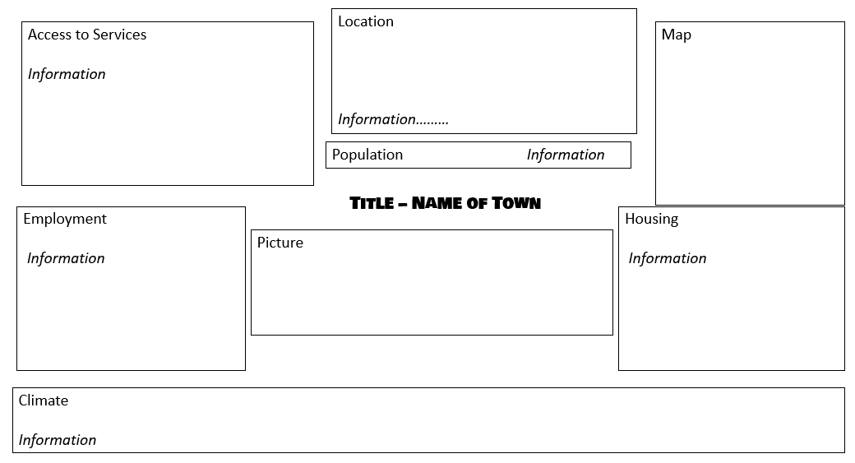**Poster - Template**

**Strategy Write Up (Template)**

**Introduction**

The survey of residents of TOWN indicates that……. Needs to be improved.

One strategy that can do this, is ………. This strategy has been used in European Country before.

*Insert information about European Liveability here (from table)*

This strategy can be implemented within TOWN.

*Insert information about implementation of strategy here (from table)*

INCLUDE: pictures of strategy and Map. Describe where in town you will introduce this and how.

